**NUMPY**

**Introduction**

* **NumPy** stands for **Numerical Python**.
* Provides highly optimized **multidimensional arrays**.
* But it is different from ordinary Python **array** or **list**.

**NumPy Array**

Creation:-



Accessing elements:-



Some common functions:-



**Special Arrays**

Bit arrays:-



Random & constant arrays:-



Constant array with defined data type:-



Empty and identity matrix:-



**Copying Array**



* **loadtxt()** is used for loading a NumPy **array** from a **text file**.
* **savetxt()** is used for saving a NumPy **array** to a **text file**.

**Sequencing**



**Reshaping and Resizing**

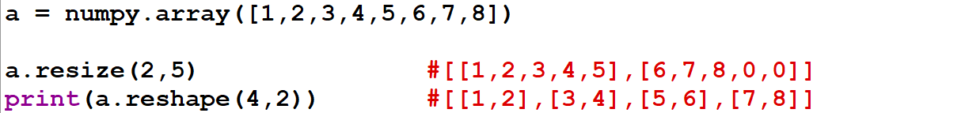

* **resize()** **reshapes** the array & fills the **leftover spaces** with **zeroes** (if any).
* **reshape()** **strictly reshapes** the array & throws **error** otherwise.
* **reshape()** however **doesn’t** actually change the array but **represents** it in that way.

**Flattening Array**



* **ravel()** also **doesn’t** change the array’s actual properties.

**Transposing the Matrix**



* **transpose()** also **doesn’t** change array’s actual properties.

**Array Slicing**

Linear array:-



Multidimensional array:-

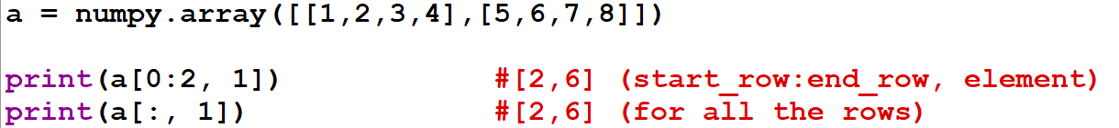

* If a **slice** is assigned to a variable, then making changes to it changes the original array too.

**Arithmetic Functions**

* Done between **two** NumPy arrays.
* Can be done using **functions** & **operators** both.

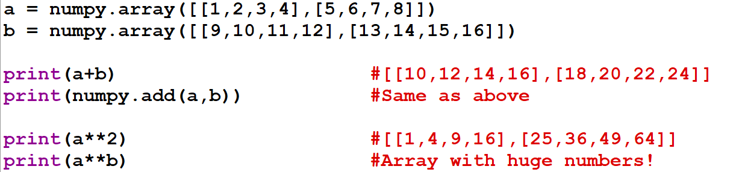

* Even **relational operators** can be applied on them.

**Matrix Dot Product**

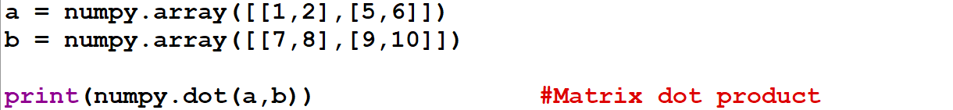

**Elementwise Functions**

Exponent and square roots:-

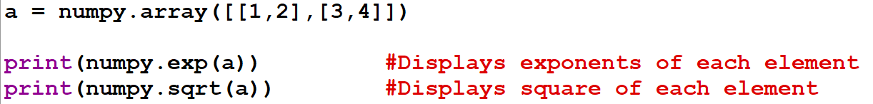

Specifically for floats:-



**Array Functions**

Non-axial (normal):-

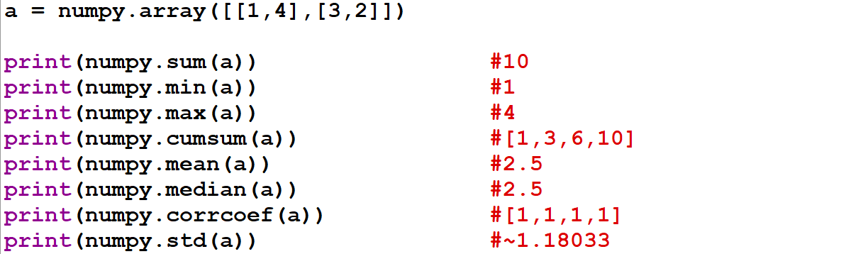

* **Cumulative sum:** Summing up all the values while **positive linear traversing**.
* **Median:** The **middle** value in an **increasing order** data.
* **Correlation coefficient:** **1** if next value is **larger**, **-1** if next value is **smaller** & **0** if **no** change. Works in a **circular** manner.
* **Standard deviation:** Average of squared values of difference between **each data** & **mean**.

Axial (operation on only row or column):-

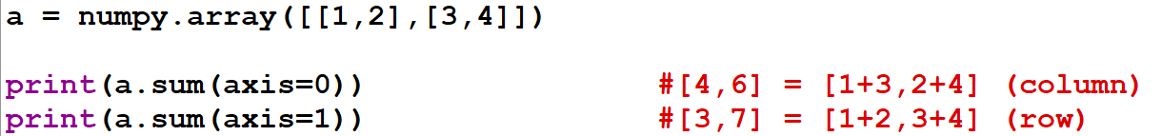

**Broadcasting**

* Used to allow operation between a **one-dimensional array** & a **multi-dimensional array**.
* Works by stretching the **one-dimensional array** to the **shape** & **size** of the **multi-dimensional array**.

